Isaiah Alfred
Amarikiya Stephens
Group A Info Systems And Design Dev
Florida agricultural & Mechanical University

2. Database Design (Relational Model)
FAMU Mentorship Bridge System
2.1 Overview of Database Approach
The FAMU Mentorship Bridge System uses a relational database (SQL) because the system depends on structured data and clear relationships between students, alumni, mentorship requests, and communications. A relational model ensures data consistency, supports ACID properties, and enforces integrity through primary and foreign keys. This approach is ideal for managing verified institutional users and structured mentorship workflows.

2.2 ERD (Entity Relationship Diagram)
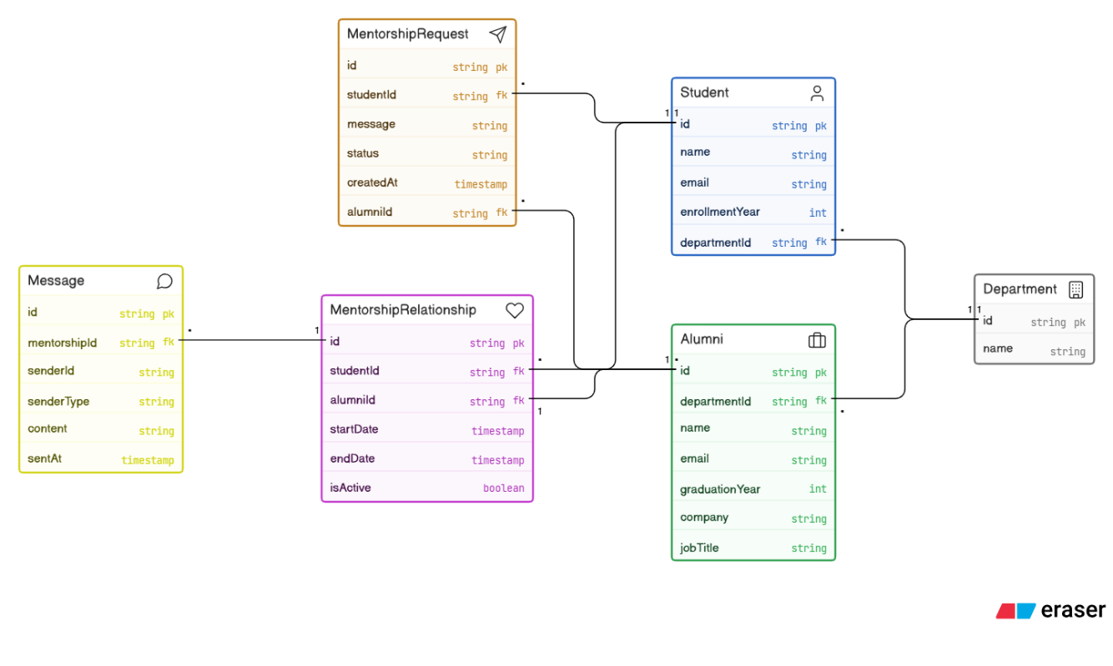
The system includes six main entities: Student, Alumni, Mentorship Request, Mentorship Relationship, Message, and Department. These entities are connected through defined relationships that allow students and alumni to interact through structured mentorship connections.

2.3 Key Relationships
- Students submit multiple mentorship requests (one-to-many).
- Alumni receive multiple mentorship requests (one-to-many).
- Approved requests create a Mentorship Relationship (many-to-many resolved entity).
- Each Mentorship Relationship contains multiple Messages (one-to-many).
- Students belong to one Department, while a Department has many students (one-to-many).
These relationships ensure organized communication and prevent data duplication.
2.4 Normalization
The database is normalized to Third Normal Form (3NF). Data is separated into distinct tables to reduce redundancy and ensure consistency. Each table stores only attributes directly related to its primary key, and foreign keys are used to maintain relationships between entities.
2.5 Design Summary
This relational design ensures data integrity, scalability, and structured mentorship tracking. It supports secure, organized interactions between students and alumni while maintaining efficient data management across the system.

